**COA LAB WEEK 7**

**Name : PRATHAM MAHESHWARI**

**Enrolment No; 9920103029**

**Q1.** Write an assembly program for addition and subtraction of two 8-bit & 16 bit numbers using 8086 microprocessor.

**Addition :**

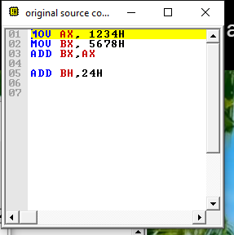

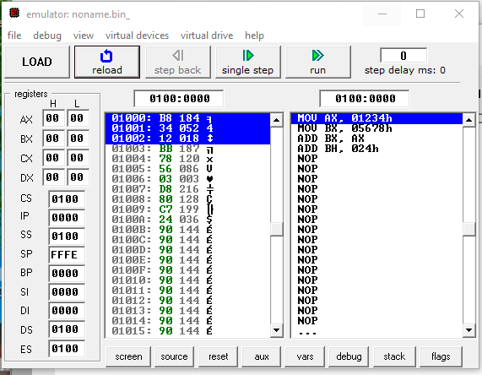

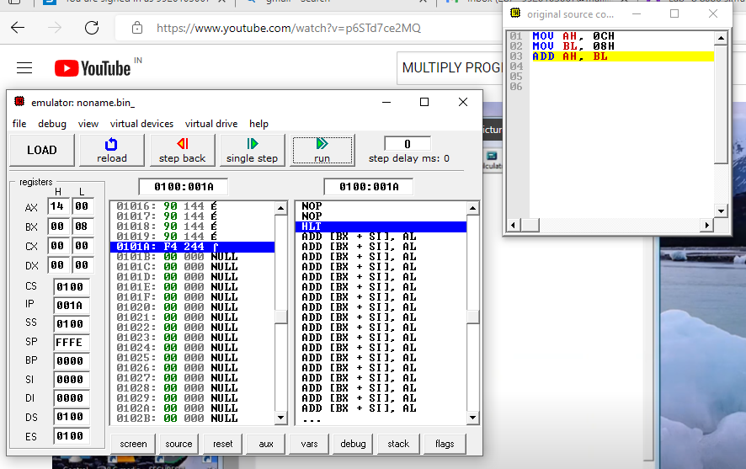

**Subtract :**

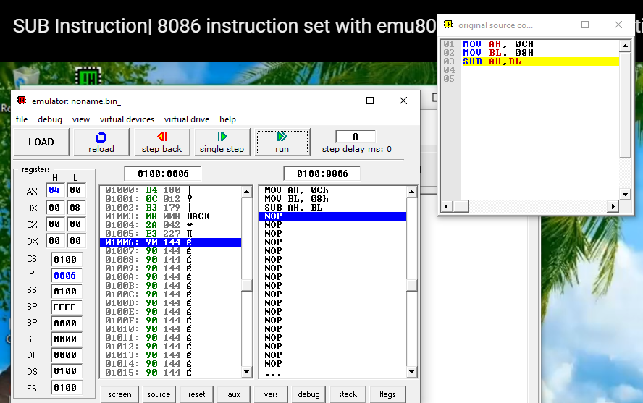

**Q2.**

Write an assembly program for Multiplication & Division of two 8-bit numbers.

**Multiply :**

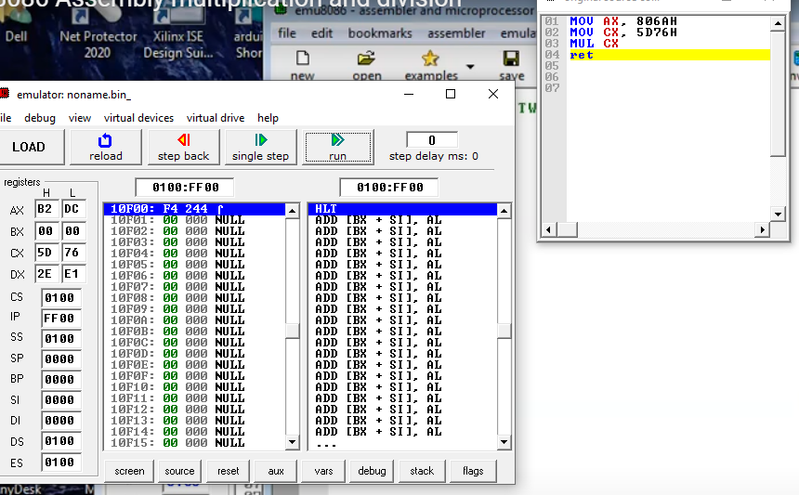

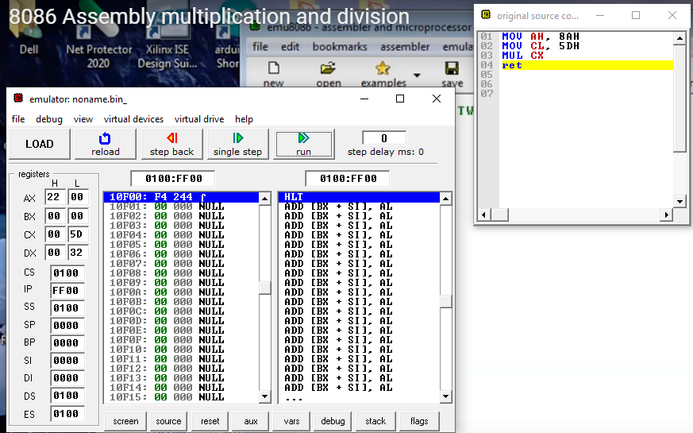

**Divide :**

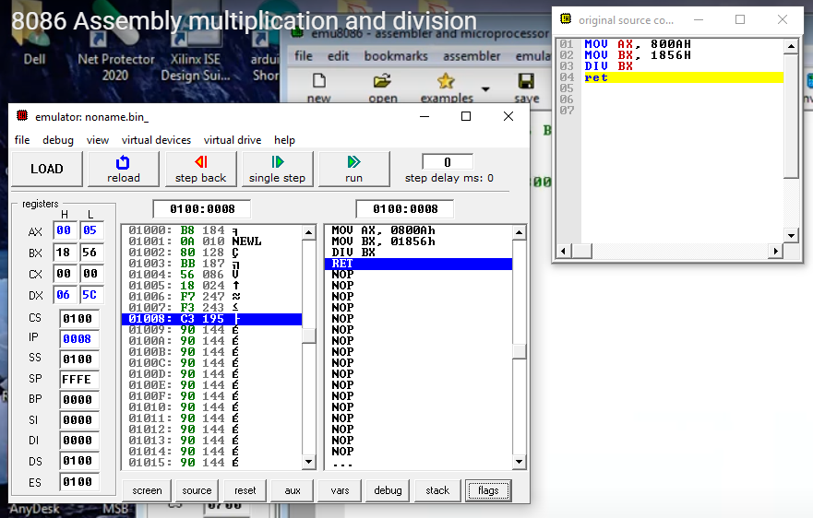

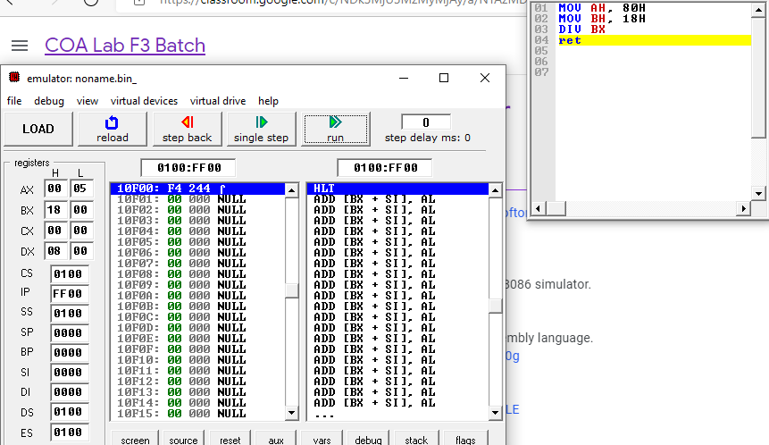

**Q3.**  Write an assembly program for Largest & Smallest among N numbers

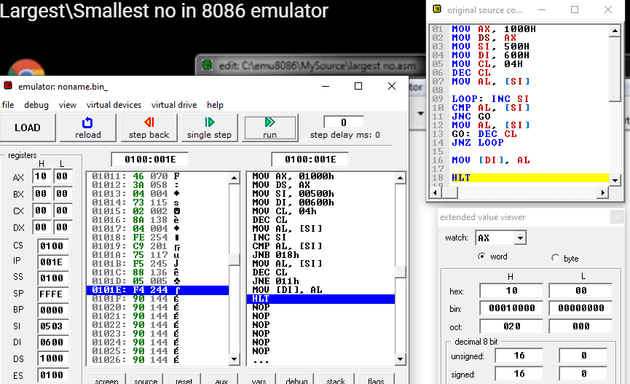

**Q4.** Write an assembly program for Factorial of N number.

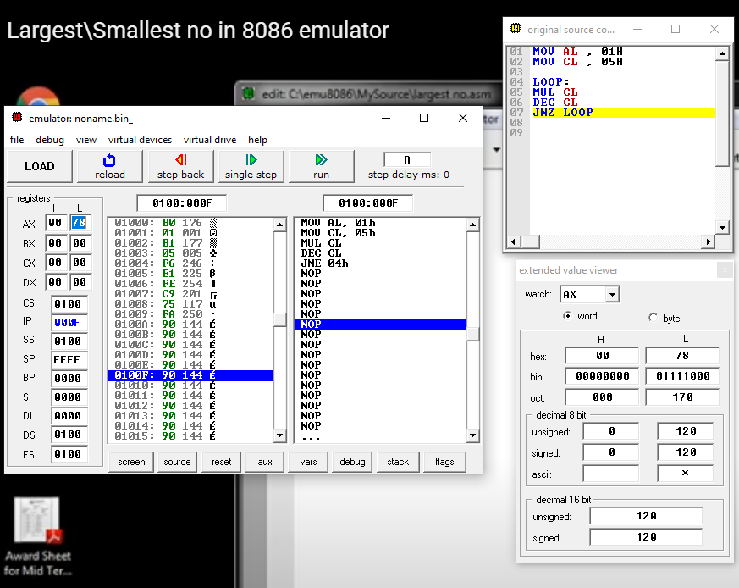

**Q5.** Sort the numbers stored from location 2000H in ascending order.

ASCENDING ORDER ::

MOV [2000H] , 25H

MOV [2001H] , 15H

MOV [2002H] , 45H

MOV [2003H] , 35H

MOV [2004H] , 55H

MOV SI , 2000H

MOV DX, 2001H

MOV CH, 04H

BACK1:

MOV CL, CH

MOV DI, DX

BACK:

MOV AL, [SI]

MOV BL, [DI]

CMP AL, BL

JNC NEXT

MOV [SI], BL

MOV [DI], AL

NEXT:

INC DI

DEC CL

JNZ BACK

INC SI

INC DX

DEC CH

JNZ BACK1

RET

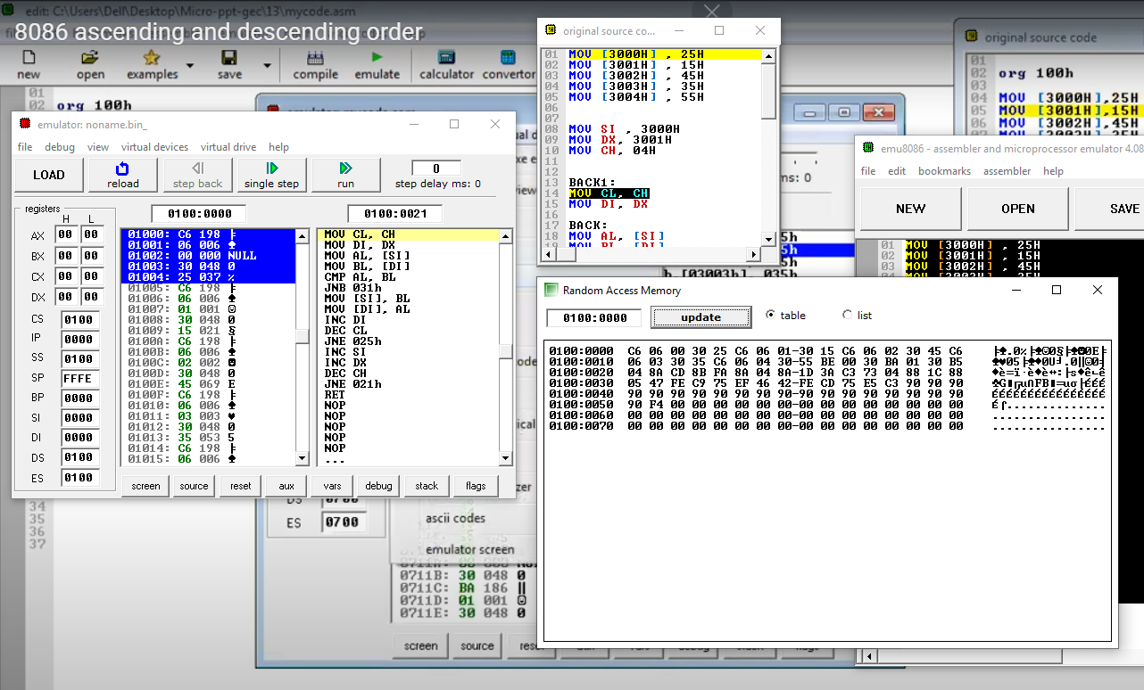

Q6. Sort the Numbers Stored from 2000H in DESCENDING ORDER:

MOV [2000H] , 25H

MOV [2001H] , 15H

MOV [2002H] , 45H

MOV [2003H] , 35H

MOV [2004H] , 55H

MOV SI, 2000H

MOV DX, 2001H

MOV CH, 04H

BACK1:

MOV CL, CH

MOV DI,DX

BACK:

MOV AL, [SI]

MOV BL, [DI]

CMP AL,BL

JC NEXT

MOV [SI], BL

MOV AL,[DI]

NEXT:

INC DI

DEC CL

JNZ BACK

INC SI

INC DX

DEC CH

JNZ BACK1

RET

